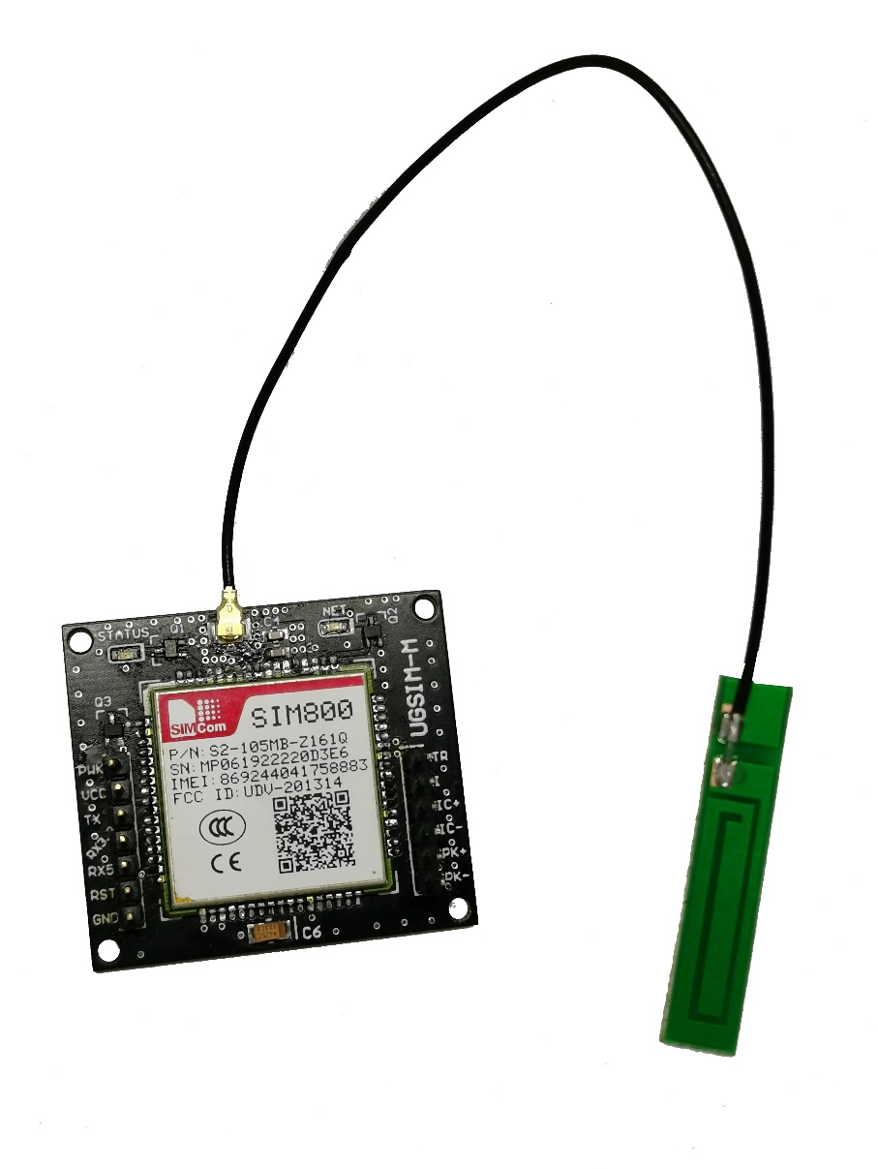

UGSIM-M USER MANUAL

VER 1.1

## Introduction:

UGSIM-M is a GSM/GPRS module designed by UGE electronics and based on SIMCOM SIM800 Quad-band GSM/GPRS engine, featuring a compact size, solid protection, and compatibility with 5V and 3.3V levels.

## Features:

* Quad-band 850/900/1800/1900MHz
* Controlled by AT Command
* Compatibility with TTL and 3.3 voltage levels
* Protection against ESD and Battery overvoltage
* Supports GSM (SMS and dialing)
* Supports GPRS

## Electrical Characteristics:

|  |  |  |  |  |
| --- | --- | --- | --- | --- |
| Parameters | Min | Typical | Max | Unit |
| Input Voltage (VCC) | 3.4 | 4 | 4.4 | VDC |
| Peak Current | - | - | 2 | A |
| Average Current | - | - | 500 | mA |

# Layout Description



|  |  |
| --- | --- |
| Name | Description |
| PWK | Power key pin, this pin is used to power up/power down the module, for power up/power down you need the send high pulse for 1.2 s, the pin is 5V and 3.3V tolerant. |
| VCC | Power pin for the module, the power supply voltage range is from 3.4V to 4.4V. Power supply should provide enough current so that the module can work normally; the peak current is nearly 2A. |
| TX | UART transmit pin, note that this pin work on 3.3V logic level (i.e. sends signals on 3.3V levels), but can work reliably with 5V level receivers without any conversion as 3.3V is read high in 5V logic level. |
| RX3.3 | UART 3.3V receive pin, use this pin **only** with devices that sends 3.3V logic level signals. |
| RX5 | UART 5V receive pin, use this pin **only** with devices that send 5V logic level signals. |
| RST | Reset input (active High) compatible with 3.3V and 5V logic levels |
| GND | Circuit ground |
| DTR | UART data terminal ready |
| RI | Ring indicator |
| M+ | Mic differential audio input |
| M- | Mic differential audio input |
| S+ | Speaker differential audio output |
| S- | Speaker differential audio output |
| ANT | Antenna interface, this is a u.fl connector |
| STATUS | The STATUS LED indicates the operating status of module. The pin output high when module power on, output is low when module powered off |
| NET | The NET led is a network status indicator and behaves as follows:   |  |  | | --- | --- | | **NET led** | **SIM800 behavior** | | Off | SIM800 is not running | | 64ms On/ 800ms Off | SIM800 not registered the network | | 64ms On/ 3000ms Off | SIM800 registered to the network | | 64ms On/ 300ms Off | GPRS communication is established | |

# Mechanical Design



# External references:

* [SIM800_Hardware Design_V1.10](http://www.simcom.com/download/down.php?id=668&lang=en)
* [SIM800 Series AT Command Manual_V1.10](http://www.simcom.com/download/down.php?id=666&lang=en)